 | 

Guideline on Course Selection
(For Foreign Postgraduates)

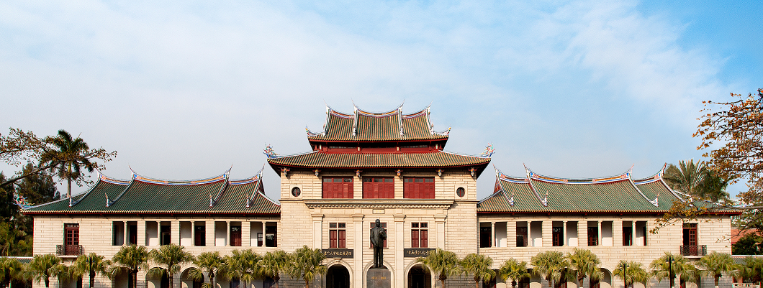

Graduate School
Spring Semester of 2013-2014

TABLE OF CONTENTS
Schedule: 1
Important notes 1
Course Introduction 3
Graduate School General Courses Timetable 12

Schedule:
Registration Period ： | Feb. 17th to Feb. 21st
Deadline of Course Withdrawal： | Feb. 28 th

Important notes
- Postgraduate students (except for exchange students and scholars) can register their courses via the on-line course registration system during the course registration period.
- There are two periods for course selection in each academic year, one in late August/early September (Autumn Semester) and the other in January/February (Spring Semester). The actual dates vary from year to year depending on the academic calendar.
- Curriculum schedule of spring semester for English taught programs can be downloaded from the Graduate School homepage http://gs.xmu.edu.cn/en/.
- Students are strongly encouraged to consult their supervisors or program secretary on the courses they should take before the course selection.
- Prepare for Course Selection
  - Go through the regulations.
  - Check the study schedule of your program.
  - Check the teaching timetable.
  - Check the course selection schedule and confirm whether selection of courses is required by your Program.
- Students can sign up for or withdraw courses during the course registration period. The course withdrawal deadline is normally one week longer than the course selection period (please refer to the schedule of the relevant semester). After the course withdrawal period, students will not be allowed to drop courses.
- Students who fail to complete the entire lessons or to participate in course work and examinations will receive zero for that course.
- Please be reminded that the course selection system may get “crowded” when the deadline is near.

*Important notes for exchange students and scholars
- The secretary of the school where exchange students and scholars enrolled will help with course selection.
- If the exchange students and scholars want to take course(s) from another school, please obtain approval from the secretary of the relevant school.
- At the end of each semester，exchange students and scholars should submit one hard-copy of the course selection form to the secretary of the school where they enrolled. Failure to do so may result in delay of the transcript issuance.

Course Introduction
Postgraduate courses are generally divided into three categories: general courses, required courses and optional courses. General courses are offered by the graduate school.
Following is the introduction of general courses and English teaching courses：

General Courses
There are two required General Course modules:
1. Chinese Language
- 汉语通论(Taught in Chinese) or
- Rudiments of Chinese Language (Taught in English)

- Introduction to China
- 中国概况(Taught in Chinese) or
- Selected Issues on China (Taught in English)

Teaching  Language | Targeted students | Course 1 | Course 2
English  Program | PhD candidate | Rudiments of Chinese Language | Selected Issues on China
English  Program | postgraduate | Rudiments of Chinese Language | Selected Issues on China
Chinese Program | PhD candidate | 汉语通论 | 中国概况
Chinese Program | postgraduate | 汉语通论 | 中国概况

Exemption from the General Courses
Students who have successfully completed the required course(s) or equivalent(s), either from XMU or a comparable university, may apply for exemption from one or two course(s). Applicants should submit one hard-copy of the course exemption form which can be downloaded from the Graduate School homepage with the approval of relevant schools. Applicants also need to provide documentary evidence of having attended and passed relevant course(s) or an equivalent. Exemption from general courses is subject to the approval of the Graduate School on a case-by-case basis, taking into account the individual circumstances.
Course Title | Exemption conditions
Selected Issues on China | - Majoring Chinese or relevant courses or undergraduate\ graduate in China  - Living or working in China for more than two years.
Rudiments of Chinese Language | 1.Special majors or undergraduate\ graduate in China  2. Taking the same level of Chinese language courses  3. Old HSK8 level and above, or above the level of the new HSK5
中国概况 | 1. Majoring Chinese or relevant courses or undergraduate\ graduate in China  2.Living or working in China for more than two years
汉语通论 | 1. Special majors or undergraduate\ graduate in China  2. Taking the same level of Chinese language courses  3. Old HSK8 level and above, or above the level of the new HSK5

The specific time/place/classroom/teachers and other information of these courses are available through the information platform of graduate elective system on the website of the Graduate School.

English teaching courses
The curriculum of English teaching courses offered by the Graduate School involves a number of professional fields, mainly for international graduate programs. In this semester, it includes a total of 13 professional international projects, as follows:
- Chinese Culture（School of Humanities）
- International Business（School of Economics）
- Finance（Wang Yanan Institute for Studies in Economics）
- Financial Engineering（Wang Yanan Institute for Studies in Economics）
- Western Economics（Wang Yanan Institute for Studies in Economics）
- Quantitative Economics（Wang Yanan Institute for Studies in Economics）
- Chinese Law（School of Law）
- Chemical Engineering（School of Chemistry and Chemical Engineering）
- Physical Chemistry (Electrochemistry)（School of Chemistry and Chemical Engineering）
- Marine Affairs（Coastal and Ocean Management Institute）
- International Relations（School of International Relations）
- Finance (MFin)（The Institute for Financial & Accounting Studies）
- Accounting (MAcc)（The Institute for Financial & Accounting Studies）

These courses are open for all postgraduates and PhD candidates. Students could select cross-faculty electives according to their own academic needs. The specific time/place/classroom/teachers and other information of each course are available through the information platform of graduate elective system on the website of the Graduate School.
Operation method

The following is a step-by-step guide for selecting the courses on-line:

Step 1 - Log-in:
Students should access the system via System Portal. Please visit http://gs.xmu.edu.cn/EN/ to enter the course selection screen

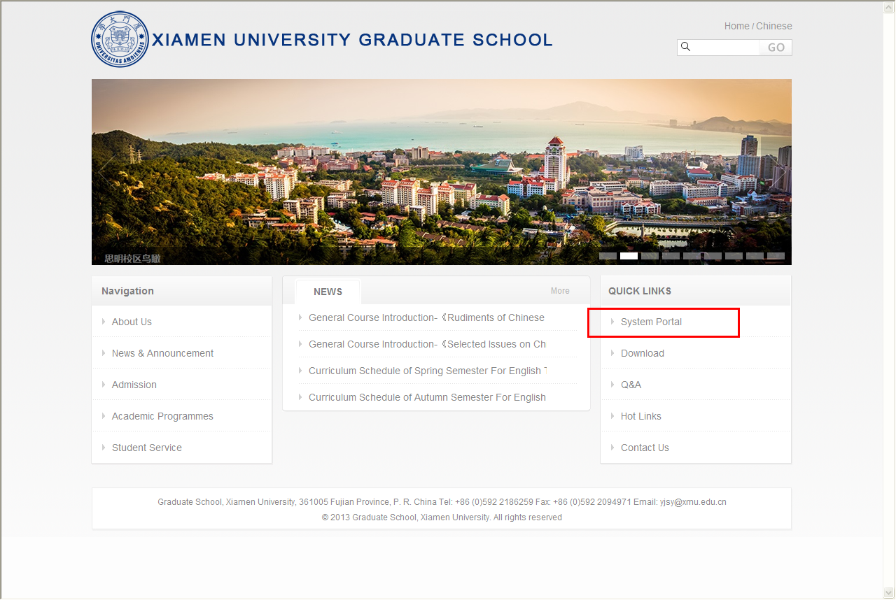
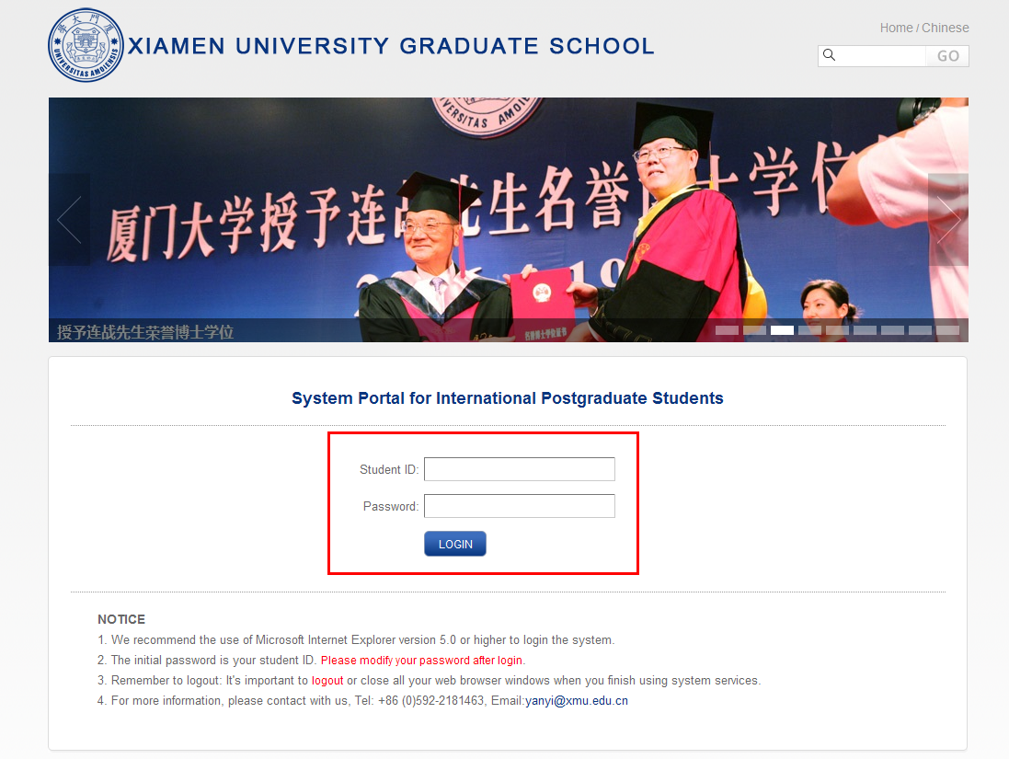
The initial password is your student ID. Find the modify password button to modify your password after login.

Find the “sign up for courses” button under the curriculum folder.
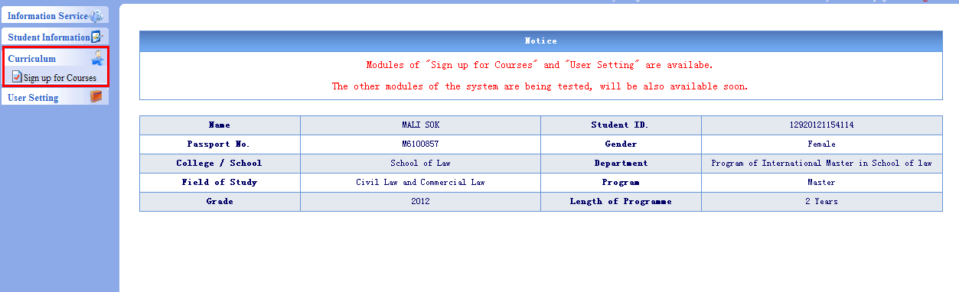

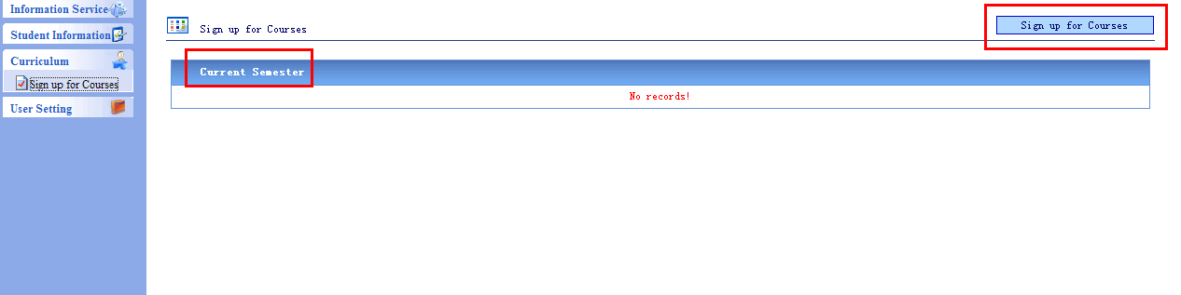

On this page，you can see the courses that you have selected and find the courses that you want to select. Click “details” to get more information.
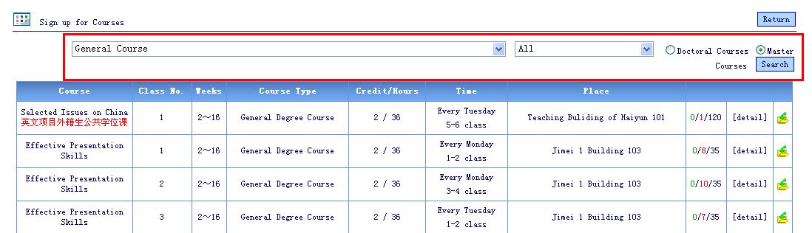

Use the drop-down list to view courses offered by different schools as illustrated below.
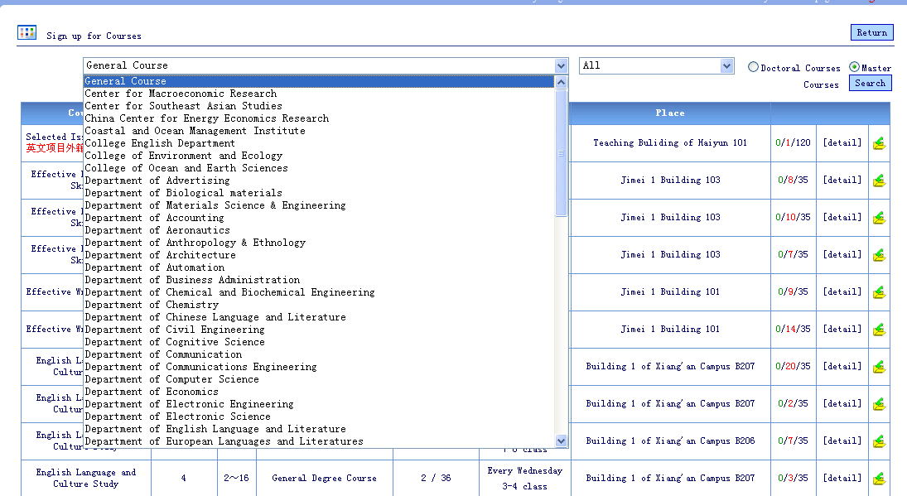

Choose “ALL” to search for courses of deferent type as below.
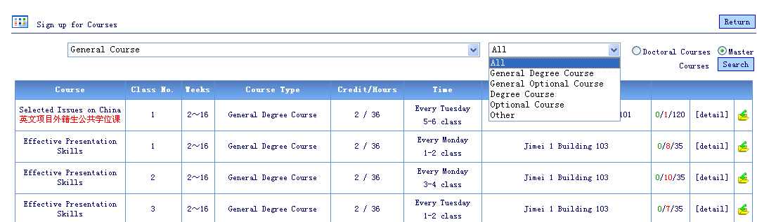

Click button to sign up for a course.
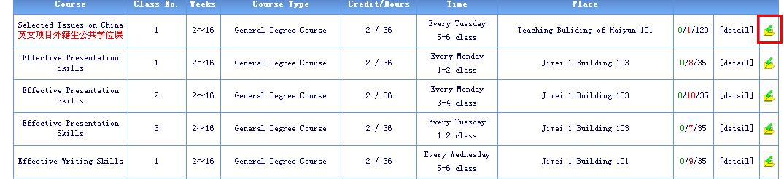

Click“是（Y）” for yes to confirm your course selection
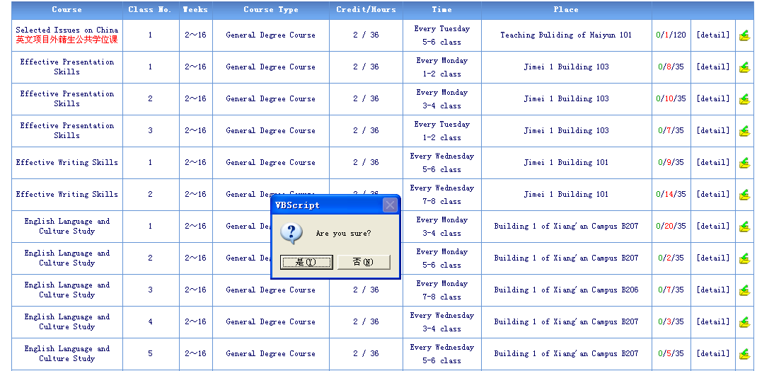

Go back to the “sign up for a course” page to check if the chosen course is on your course list.
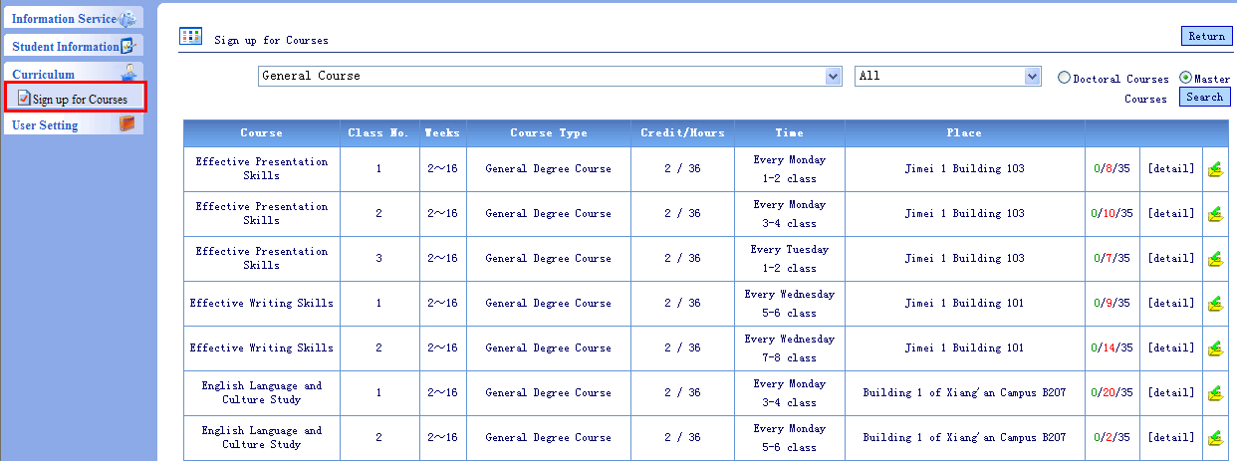

To drop courses just click the“”button.
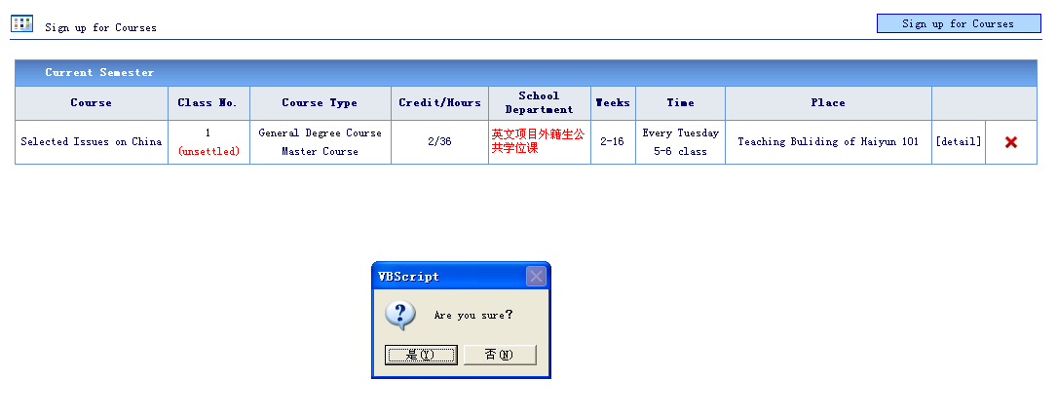

The red word “unsettled” means that the course has not been successfully chosen. If you successfully get into the class, the red “unsettled” will change to green “settled”. The course status will be changed after the deadline of each course selection period. Students who do not successfully register in their desired course(s) in the first or second period can choose to sign up for other available course(s) in a subsequent period. Students will not be able to register for courses after the course selection period ends.
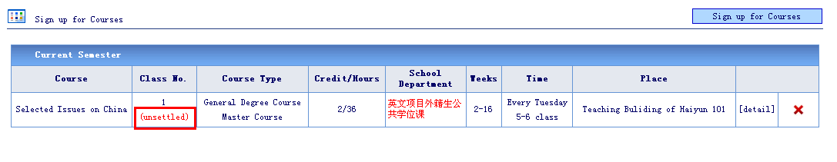

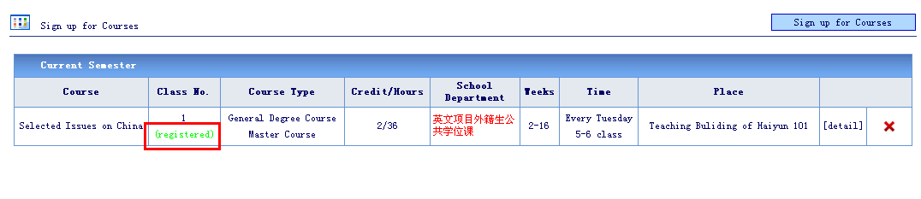

Graduate School General Courses Timetable
Courses | Instructors | Time | Campus | Lecture room
中国概况  （Taught in Chinese） | Chang Daqun | Every Thursday  14:30-17:30 | Xiang’an Campus | Room B206, Xuewu Bldg.
汉语通论  （Taught in Chinese） | Zeng Xiaohong | Every Wednesday 8:00-12:00 | Xiang’an Campus | Room B313, Xuewu Bldg.

*The Graduate School will offer《Rudiments of Chinese Language（Taught in English）》 and 《Selected Issues on China（Taught in English）》 in the fall semester.

