 | 

Guideline on Course Selection
(For Foreign Postgraduates)

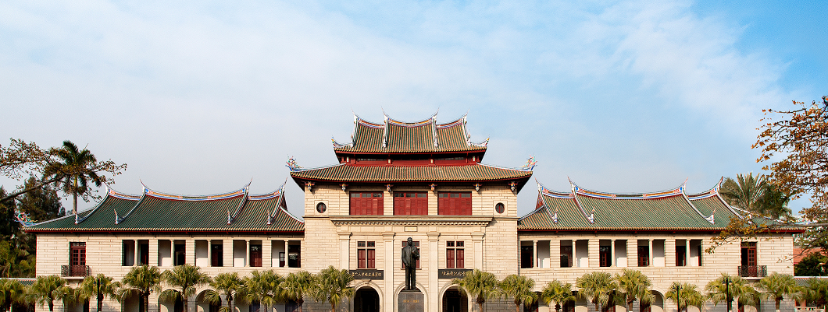

Graduate School
Spring Semester of 2014-2015

TABLE OF CONTENTS
Schedule: 1
Important notes 1
Course Introduction 3
Curriculum Schedule of Spring Semester For English Taught Programmes(2014-2015) 12

Schedule:
Round 1 : 26th January to 27th February
Round 2: 28th February to 4th March
Round 3: 5th March to 8th March
Deadline of other course cancelling: 20th March

Important notes
- Postgraduate students can register their courses via the on-line course registration system during the course registration period.
- There are two periods for course selection in each academic year, one in late August/early September (Autumn Semester) and the other in January/February (Spring Semester). The actual dates vary from year to year depending on the academic calendar.
- Students are strongly encouraged to consult their supervisors or program secretary on the courses they should take before the course selection.
- Prepare for Course Selection
  - Go through the regulations.
  - Check the study schedule of your program.
  - Check the teaching timetable.
  - Check the course selection schedule and confirm whether selection of courses is required by your Program.
- Students can sign up for or withdraw courses during the course registration period. The course withdrawal deadline is normally one week longer than the course selection period (please refer to the schedule of the relevant semester). After the course withdrawal period, students will not be allowed to drop courses.
- Students who fail to complete the entire lessons or to participate in course work and examinations will receive zero for that course.
- Please be reminded that the course selection system may get “crowded” when the deadline is near.

Course Introduction
Postgraduate courses are generally divided into three categories: general courses, compulsory courses and optional courses. General courses are offered by the graduate school.

Exemption from the General Courses
Students who have successfully completed the required course(s) or equivalent(s), either from XMU or a comparable university, may apply for exemption from one or two course(s). Applicants should submit one hard-copy of the course exemption form which can be downloaded from the Graduate School homepage with the approval of relevant schools. Applicants also need to provide documentary evidence of having attended and passed relevant course(s) or an equivalent. Exemption from general courses is subject to the approval of the Graduate School on a case-by-case basis, taking into account the individual circumstances.
Course Title | Exemption conditions
Selected Issues on China | - Majoring Chinese or relevant courses or undergraduate\ graduate in China  - Living or working in China for more than two years.
Rudiments of Chinese Language | 1.Special majors or undergraduate\ graduate in China  2. Taking the same level of Chinese language courses  3. Old HSK8 level and above, or obtain at least 210 in new HSK5 and above
Elementary Chinese Reading and Writing（1st）
中国概况 | 1. Majoring Chinese or relevant courses or undergraduate\ graduate in China  2.Living or working in China for more than two years
现代汉语通论 | 1. Special majors or undergraduate\ graduate in China  2. Taking the same level of Chinese language courses  3. Old HSK8 level and above, or above the level of the new HSK5

The specific time/place/classroom/teachers and other information of these courses are available through the information platform of graduate elective system on the website of the Graduate School.

English teaching courses
The curriculum of English teaching courses offered by the Graduate School involves a number of professional fields, mainly for international graduate programs. In this semester, it includes a total of 15 professional international projects, as follows:

No. | Programmes | Colleges/Schools
1 | Chinese Philosophy | School of Humanities
2 | Civil and Commercial Law | School of Law
3 | International Relations | College of International Relations
4 | International Trade | School of Economics
5 | Marine Affairs | Coastal and Ocean Management Institute
6 | Chemical Engineering | College of Chemistry and Chemical Engineering
7 | Physical Chemistry | College of Chemistry and Chemical Engineering
8 | Computer Science and Technology | School of Information Science and Technology
9 | Finance | Wang Yanan Institute for Studies in Economics
10 | Financial Engineering | Wang Yanan Institute for Studies in Economics
11 | Western Economics | Wang Yanan Institute for Studies in Economics
12 | Quantitative Economics | Wang Yanan Institute for Studies in Economics
13 | Management Economics | Wang Yanan Institute for Studies in Economics
14 | Finance | Institute for Financial & Accounting Studies
15 | Accounting | Institute for Financial & Accounting Studies

These courses are open for all postgraduates and PhD candidates. Students could select cross-faculty electives according to their own academic needs. The specific time/place/classroom/teachers and other information of each course are available through the information platform of graduate elective system on the website of the Graduate School.
Operation method

The following is a step-by-step guide for selecting the courses on-line:

Step 1 - Log-in:
Students should access the system via System Portal. Please visit http://gs.xmu.edu.cn/EN/ to enter the course selection screen

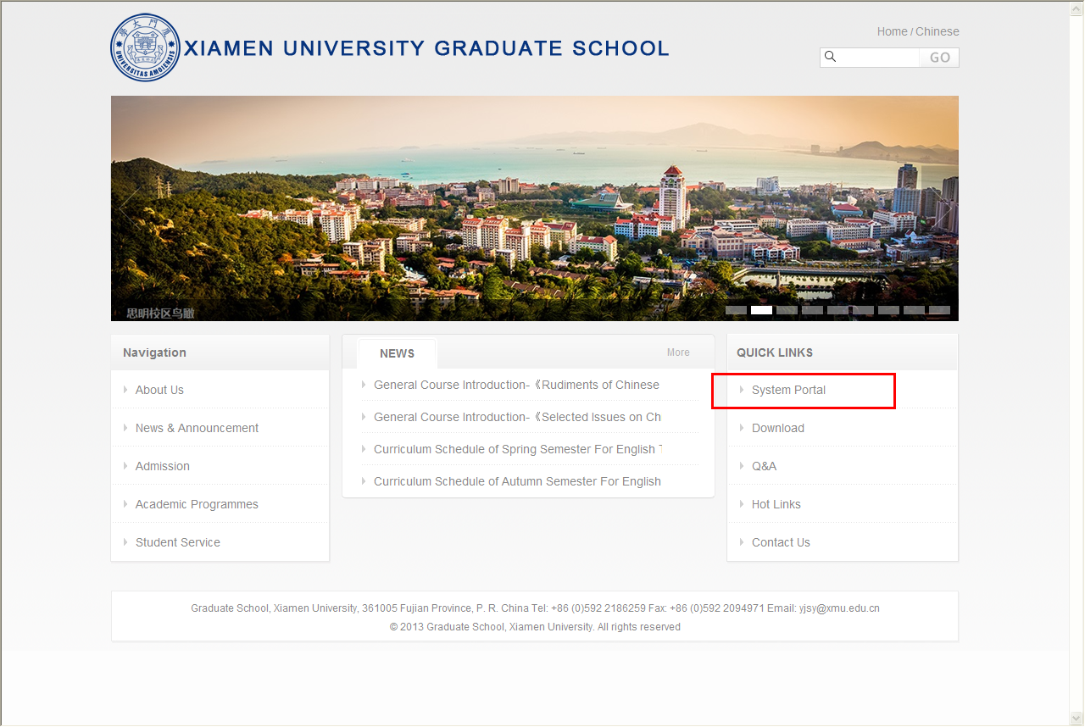
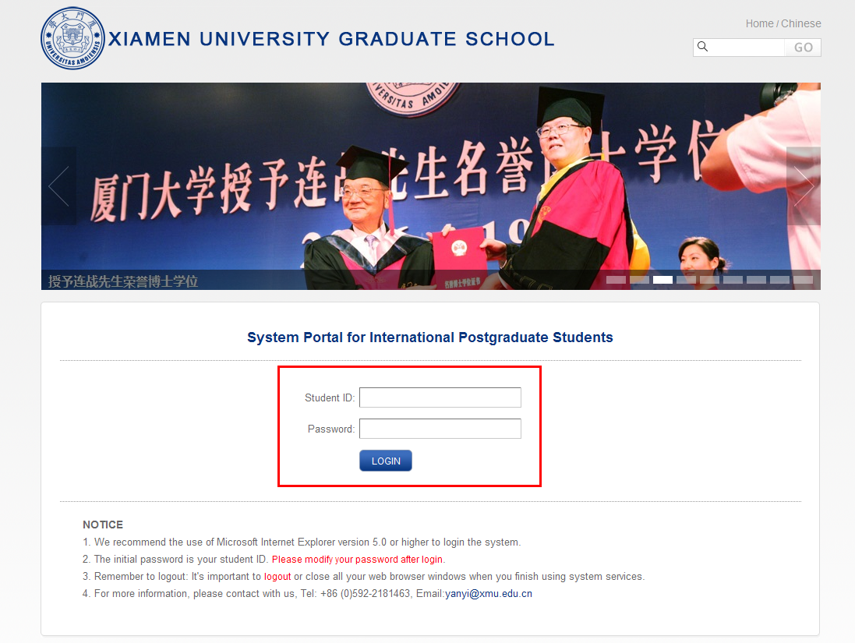
The initial password is your student ID. Find the modify password button to modify your password after login.

Find the “sign up for courses” button under the curriculum folder.
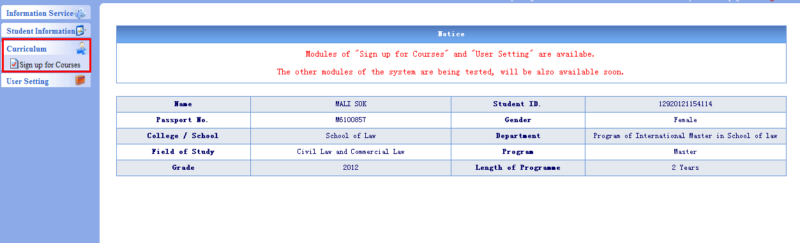

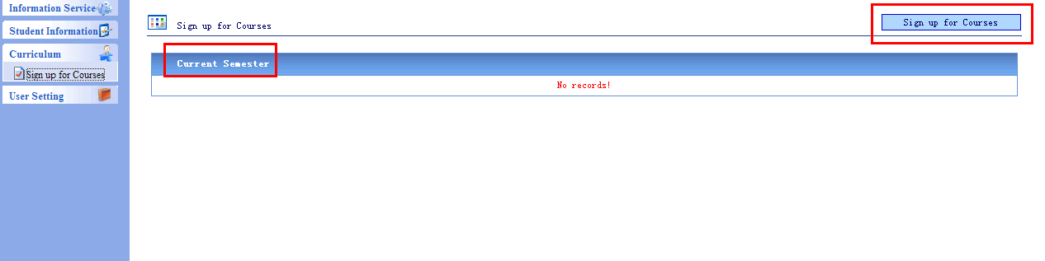

On this page，you can see the courses that you have selected and find the courses that you want to select. Click “details” to get more information.
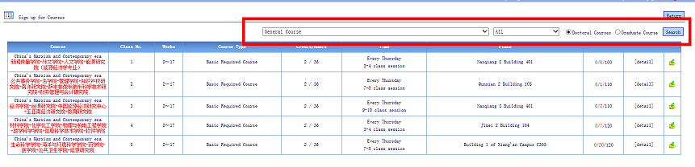

Use the drop-down list to view courses offered by different schools as illustrated below.
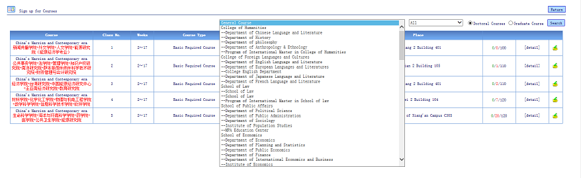

Choose “ALL” to search for courses of deferent type as below.
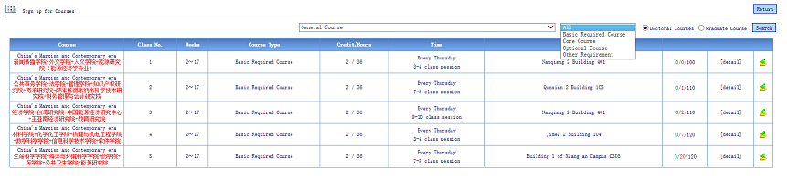

Click button to sign up for a course.
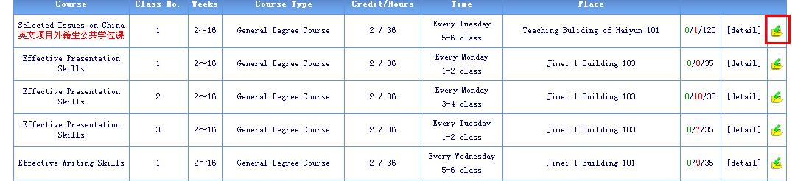

Click “YES” to confirm your course selection
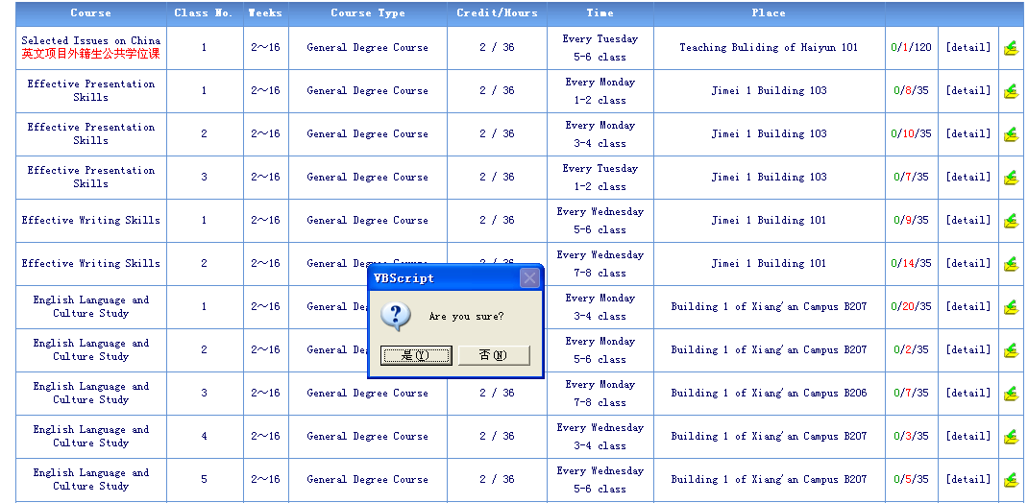

Go back to the “sign up for a course” page to check if the chosen course is on your course list.
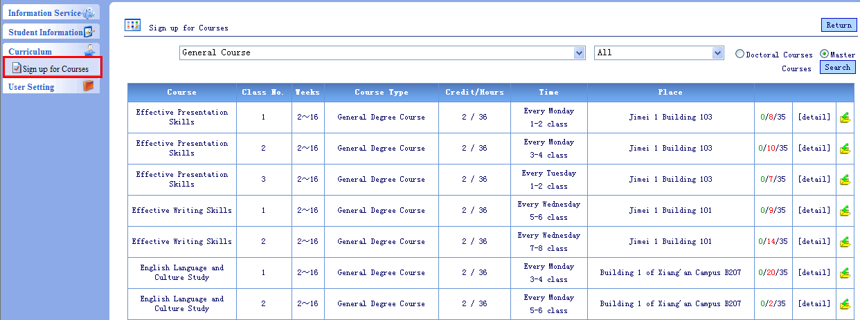

To drop courses just click the“”button.
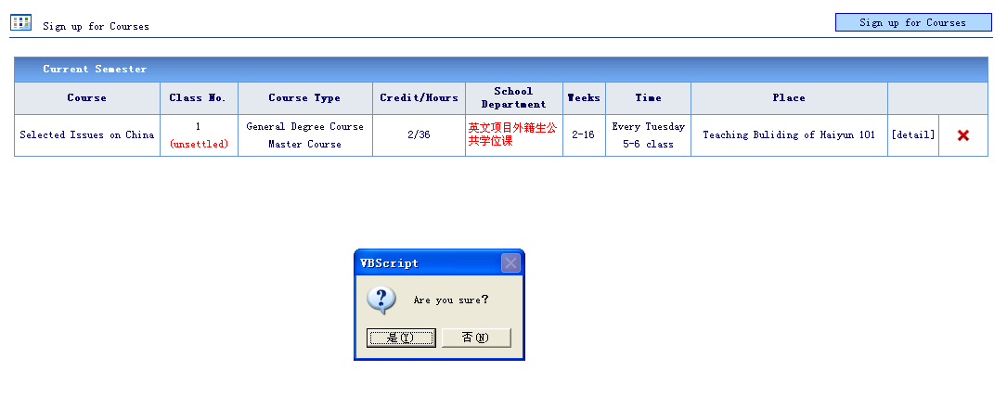

The red word “unsettled” means that the course has not been successfully chosen. If you successfully get into the class, the red “unsettled” will change to green “settled”. The course status will be changed after the deadline of each course selection period. Students who do not successfully register in their desired course(s) in the first or second period can choose to sign up for other available course(s) in a subsequent period. Students will not be able to register for courses after the course selection period ends.
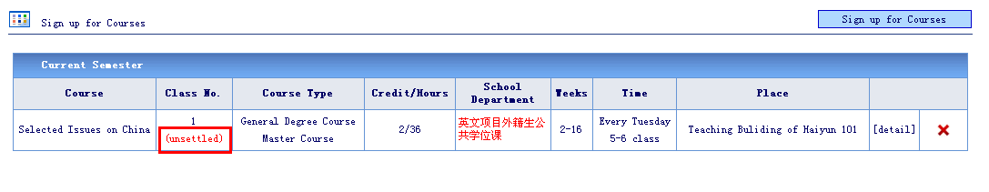

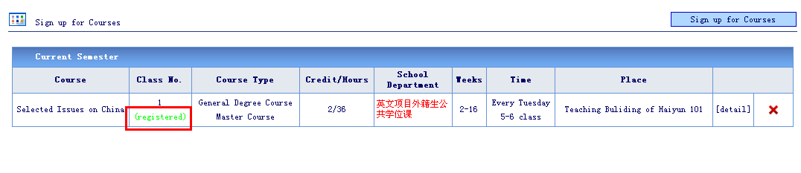

Curriculum Schedule of Spring Semester For English Taught Programmes(2014-2015)
School | Courses | Instructors | Time | Lecture room | Campus | Remarks
School of Chemistry& Chemical Engineering | Electrochemical Energy Conversion and Storage | Quanfeng Dong | Every Friday 10:40-11:50 | Room 234, Chemistry Bldg. | Siming
School of Chemistry& Chemical Engineering | Overview of AI and its Applications in Chemical and Biochemical Engineering | Chen Binghui | Every Tuesday 10:10-11:50 | Room 112, chemistry report building | Siming
School of Chemistry& Chemical Engineering | Advanced Chemical Reaction Engineering | Chen Binghui | Every Tuesday 14:30-17:25 | Room 105, chemistry report building | Siming
School of Chemistry& Chemical Engineering | Catalyst Engineering | Xia Wensheng | Every Friday 10:10-11:50(from 5th week-16th week) | Room 105, chemistry report building | Siming
School of Chemistry& Chemical Engineering | Separation Science and Technology | Liu Qinglin | Every Wednesday 8:55-11:50 | Room 105, chemistry report building | Siming
Law School | Intellectual Property Law | Lin Xiuqin, Guo Yimei | Every Tuesday 9:00-11:00 | Room B321, Law School | Siming
Law School | Foreign Investment Law | Zeng Huaqun | Every Tuesday 14:30-16:30 | Room B321, Law School | Siming
Law School | Chinese Financial Law | Chen Huiping | Every Wednsday 9:00-12:00 | Room B321, Law School | Siming
Law School | Chinese Tax Law | Liao Yixin | Every Wednsday 14:30-16:30 | Room B321, Law School | Siming
Law School | Tort Law | Zhang Huang, Chen Xin | Every Thursday 10:00-12:00 | Room B321, Law School | Siming
Coastal and Ocean Management Institute | Marine Policy and Law | Zhu Xiaoqin | Every Monday 10:10-11:50 | Rm. B206, Building of CEE | Xiang'an | CEE refres to College of the Environment and Ecology
Coastal and Ocean Management Institute | Marine Ecosystem Management | Huang Lingfeng | Every Wednesday 10:10-11:50 | Rm. B206, Building of CEE | Xiang'an | CEE refres to College of the Environment and Ecology
Coastal and Ocean Management Institute | Overview of Marine Pollution | Cai Minggang | Every Wednesday 14:30-16:10 from 5th-14th Week | Rm. B206, Building of CEE | Xiang'an | CEE refres to College of the Environment and Ecology
Coastal and Ocean Management Institute | Overview of Marine Pollution | Cai Minggang | Friday 14:30-16:10 on the 6th, 8th and 10th Week | Rm. B303, Building of CEE | Xiang'an | CEE refres to College of the Environment and Ecology
Coastal and Ocean Management Institute | Marine Spatial Planning | Fang Qinhua | Every Thursday 10:10-11:50 | Rm. B206, Building of CEE | Xiang'an | CEE refres to College of the Environment and Ecology
Coastal and Ocean Management Institute | Economics of Marine Resources and Environment | Peng Benrong | Every Thursday 14:30-16:10 | Rm. B206, Building of CEE | Xiang'an | CEE refres to College of the Environment and Ecology
Coastal and Ocean Management Institute | Public Policy Analysis | Chen Fang | Friday of Odd Weeks 8:00-11:50 | Rm. B206, Building of CEE | Xiang'an | CEE refres to College of the Environment and Ecology
Humanities School | Chinese Culture and Chinese Cultural Anthrpology | Song Ping | Every Monday 15:00-17:40 | Room 301,Nanguan 1 Bldg | Siming
Humanities School | Chinese Modern History | Sheng Jia | Every Wednesday 9:00-11:40 | Room 301,Nanguan 1 Bldg | Siming
Humanities School | An Introduction to Chinese Philosophy | Xie Xiaodong | Every Friday 9:00-11:40 | Room 301,Nanguan 1 Bldg | Siming
Institute for Financial & Accounting Studies | Financial Market | Wu Ji | Every Monday 19:10-21:45 | Room 501, Chengfeng Bldg. | Siming
Institute for Financial & Accounting Studies | Invest | Sun Zengyuan | Every Wednesday 8:55-11:50 | Room 501, Chengfeng Bldg. | Siming
Institute for Financial & Accounting Studies | Financial Mathematics and Modeling | Xu Limin | Every Thursday 14:30-17:25 | Room 501, Chengfeng Bldg. | Siming
Institute for Financial & Accounting Studies | The Analysis of Financial Statement | Liu Zhiliang | Every Thursday 19:10-21:45 | Room 501, Chengfeng Bldg. | Siming
School of International Relations | Power and Norms in International Relations | Li Meiting | Every Monday 14:30-17:25 | Room203, Nan'an Building | Siming
School of International Relations | Contemporary Security Studies: Regional Security Issues in Asia-Pacific | Xuke | Every Tuesday 8:55-11:50 | Room 203, Nan'an Building | Siming
School of International Relations | China and Ethnic Chinese in Southeast Asia | Shi Xueqin | Every Tuesday 14:30-17:25 | Room 203, Nan'an Building | Siming
School of International Relations | Development Policy and Innovative System | Huang Fei | Every Wednesday 14:30-16:10 | Room105, Nan'an Building | Siming
School of International Relations | The Craft of research:writing academic paper,proposal and thesis in English | Xu ke | Every Wednesday8:55-10:55 | Room 315, Nan'an Building | Siming
School of International Relations | Advanced Research in International Relations | Zhang Biwu | Every Thursday 8:55-11:50 | Room 203, Nan'an Building | Siming
School of International Relations | Economy and Finance in Asia-Pacific | Wu Chongbo | Every Thursday 8:55-11:51 | Room 315, Nan'an Building | Siming
School of International Relations | History of International Communication of Chinese Tea | Liu Yong | Every Friday 10:10-11:50 | Room 203, Nan'an Building | Siming
School of International Relations | Economic globalization and East Asian Economic development | Shen Hongfang | Every Friday 14:30-17:25 | Room105, Nan'an Building | Siming
Wamg Yanan Institute for Studies in Economics (WISE) | Econometrics | Brett Graham | Every Monday 14:30-16:10 | Room 406, Nanqiang 2 Bldg. | Siming | If you are an exchange student and would like to appy for WISE/SOE English courses, please visit http://www.wise.xmu.edu.cn/english/education/exchange/ for appilcation procedures.
Wamg Yanan Institute for Studies in Economics (WISE) | Econometrics | Brett Graham | Every Wednesday 14:30-16:10 | Room 501, Nanqiang 2 Bldg. | Siming
Wamg Yanan Institute for Studies in Economics (WISE) | Financial Statement Analysis | Helen Chen Clark | Every Monday 8:00-9:40 | Room 302, Nanqiang 2 Bldg. | Siming
Wamg Yanan Institute for Studies in Economics (WISE) | Financial Statement Analysis | Helen Chen Clark | Every Wednesday 10:10-11:50 | Room 302, Nanqiang 2 Bldg. | Siming
Wamg Yanan Institute for Studies in Economics (WISE) | Environmental Economics | Minqiang Zhao | Every Tuesday 16:40-18:20 | Room 109, Nanqiang 2 Bldg. | Siming
Wamg Yanan Institute for Studies in Economics (WISE) | Environmental Economics | Minqiang Zhao | Every Friday 10:10-11:50 | Room 303, Nanqiang 2 Bldg. | Siming
Wamg Yanan Institute for Studies in Economics (WISE) | Law and Economics | Xiaoning Long | Every Monday 10:10-11:50 | Room 106, Nanqiang 2 Bldg. | Siming
Wamg Yanan Institute for Studies in Economics (WISE) | Law and Economics | Xiaoning Long | Every Wednesday 8:00-9:40 | Room 102, Nanqiang 2 Bldg. | Siming
Wamg Yanan Institute for Studies in Economics (WISE) | Economic Growth | Mouhua Liao | Every Monday 16:40-18:20 | Room 308, Nanqiang 2 Bldg. | Siming
Wamg Yanan Institute for Studies in Economics (WISE) | Economic Growth | Mouhua Liao | Every Thursday 10:10-11:50 | Room 308, Nanqiang 2 Bldg. | Siming
Wamg Yanan Institute for Studies in Economics (WISE) | Time Series Analysis | Yingixng Li | Every Tuesday 10:10-11:50 | Room 405, Nanqiang 2 Bldg. | Siming
Wamg Yanan Institute for Studies in Economics (WISE) | Time Series Analysis | Yingixng Li | Every Thursday 14:30-16:10 | Room 406, Nanqiang 2 Bldg. | Siming
Wamg Yanan Institute for Studies in Economics (WISE) | Mathematical Statistics | Wei Zhong | Every Saturday 14:30-17:30 | Room 103, Qunxian 2 Bldg. | Siming
Wamg Yanan Institute for Studies in Economics (WISE) | Multivariate Statistics Analysis | Yanan He | Every Sunday 9:00-12:00 | Room 103, Qunxian 2 Bldg. | Siming
School of Economics (SOE) | Taxation in China | Wensheng Lin | Every Tuesday 14:30-16:10 | Room 204, Lianxing Bldg. | Siming
School of Economics (SOE) | Taxation in China | Wensheng Lin | Every Thursday 14:30-16:10 | Room 204, Lianxing Bldg. | Siming

