 | 

Guideline on Course Selection
(For Foreign Postgraduates)

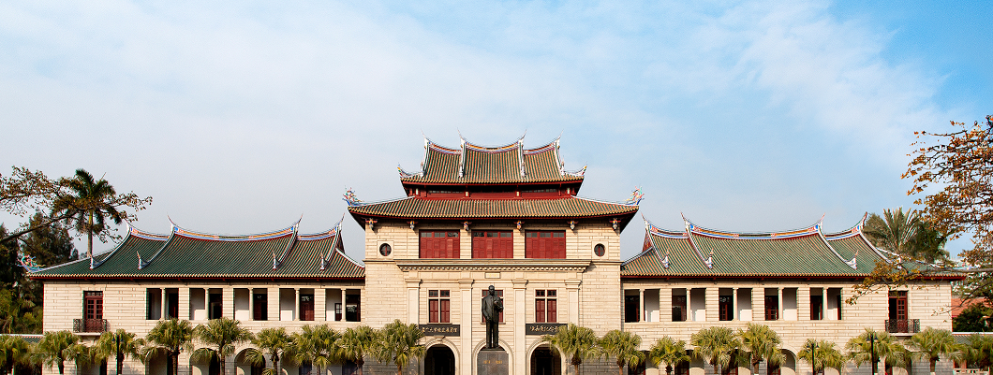

Graduate School
Autumn Semester of 2014-2015

TABLE OF CONTENTS
Schedule: 1
Important notes 1
Course Introduction 3
Graduate School General Courses Timetable 12

Schedule:
Round 1 : 9th August to 14th September
Round 2: 15th September to 18th September
Round 3: 19th September to 21st September
Deadline of basic required course cancelling (i.e. general degree course for Grade 2013 and the previous grades): 28th September
Deadline of other course cancelling: 8th October

Important notes
- Postgraduate students (except for exchange students and scholars) can register their courses via the on-line course registration system during the course registration period.
- There are two periods for course selection in each academic year, one in late August/early September (Autumn Semester) and the other in January/February (Spring Semester). The actual dates vary from year to year depending on the academic calendar.
- Curriculum schedule of spring semester for English taught programs can be downloaded from the Graduate School homepage http://gs.xmu.edu.cn/en/.
- Students are strongly encouraged to consult their supervisors or program secretary on the courses they should take before the course selection.
- Prepare for Course Selection
  - Go through the regulations.
  - Check the study schedule of your program.
  - Check the teaching timetable.
  - Check the course selection schedule and confirm whether selection of courses is required by your Program.
- Students can sign up for or withdraw courses during the course registration period. The course withdrawal deadline is normally one week longer than the course selection period (please refer to the schedule of the relevant semester). After the course withdrawal period, students will not be allowed to drop courses.
- Students who fail to complete the entire lessons or to participate in course work and examinations will receive zero for that course.
- Please be reminded that the course selection system may get “crowded” when the deadline is near.

*Important notes for exchange students and scholars
- The secretary of the school where exchange students and scholars enrolled will help with course selection.
- If the exchange students and scholars want to take course(s) from another school, please obtain approval from the secretary of the relevant school.
- At the end of each semester，exchange students and scholars should submit one hard-copy of the course selection form to the secretary of the school where they enrolled. Failure to do so may result in delay of the transcript issuance.

Course Introduction
Postgraduate courses are generally divided into three categories: general courses, required courses and optional courses. General courses are offered by the graduate school.
Following is the introduction of general courses and English teaching courses：

General Courses
There are two required General Course modules:
1. Chinese Language
- 汉语通论(Taught in Chinese) or
- Rudiments of Chinese Language (Taught in English)
- Elementary Chinese Reading and Writing（1st）(Taught in English)

- Introduction to China
- 中国概况(Taught in Chinese) or
- Selected Issues on China (Taught in English)

Teaching  Language | Targeted students | Course 1 | Course 2
English  Program | PhD candidate | Rudiments of Chinese Language（Siming Campus） | Selected Issues on China
English  Program | postgraduate | Rudiments of Chinese Language（Siming Campus） | Selected Issues on China
English  Program | postgraduate | Elementary Chinese Reading and Writing（1st）（Xiang’an Campus） | Selected Issues on China
Chinese Program | PhD candidate | 汉语通论 | 中国概况
Chinese Program | postgraduate | 汉语通论 | 中国概况

Exemption from the General Courses
Students who have successfully completed the required course(s) or equivalent(s), either from XMU or a comparable university, may apply for exemption from one or two course(s). Applicants should submit one hard-copy of the course exemption form which can be downloaded from the Graduate School homepage with the approval of relevant schools. Applicants also need to provide documentary evidence of having attended and passed relevant course(s) or an equivalent. Exemption from general courses is subject to the approval of the Graduate School on a case-by-case basis, taking into account the individual circumstances.
Course Title | Exemption conditions
Selected Issues on China | - Majoring Chinese or relevant courses or undergraduate\ graduate in China  - Living or working in China for more than two years.
Rudiments of Chinese Language | 1.Special majors or undergraduate\ graduate in China  2. Taking the same level of Chinese language courses  3. Old HSK8 level and above, or above the level of the new HSK5
Elementary Chinese Reading and Writing（1st）
中国概况 | 1. Majoring Chinese or relevant courses or undergraduate\ graduate in China  2.Living or working in China for more than two years
现代汉语通论 | 1. Special majors or undergraduate\ graduate in China  2. Taking the same level of Chinese language courses  3. Old HSK8 level and above, or above the level of the new HSK5

The specific time/place/classroom/teachers and other information of these courses are available through the information platform of graduate elective system on the website of the Graduate School.

English teaching courses
The curriculum of English teaching courses offered by the Graduate School involves a number of professional fields, mainly for international graduate programs. In this semester, it includes a total of 13 professional international projects, as follows:

No. | Programmes | Colleges/Schools
1 | Chinese Philosophy | School of Humanities
2 | Civil and Commercial Law | School of Law
3 | International Relations | College of International Relations
4 | International Trade | School of Economics
5 | Marine Affairs | Coastal and Ocean Management Institute
6 | Chemical Engineering | College of Chemistry and Chemical Engineering
7 | Physical Chemistry | College of Chemistry and Chemical Engineering
8 | Computer Science and Technology | School of Information Science and Technology
9 | Finance | Wang Yanan Institute for Studies in Economics
10 | Financial Engineering | Wang Yanan Institute for Studies in Economics
11 | Western Economics | Wang Yanan Institute for Studies in Economics
12 | Quantitative Economics | Wang Yanan Institute for Studies in Economics
13 | Management Economics | Wang Yanan Institute for Studies in Economics
14 | Finance | Institute for Financial & Accounting Studies
15 | Accounting | Institute for Financial & Accounting Studies

These courses are open for all postgraduates and PhD candidates. Students could select cross-faculty electives according to their own academic needs. The specific time/place/classroom/teachers and other information of each course are available through the information platform of graduate elective system on the website of the Graduate School.
Operation method

The following is a step-by-step guide for selecting the courses on-line:

Step 1 - Log-in:
Students should access the system via System Portal. Please visit http://gs.xmu.edu.cn/EN/ to enter the course selection screen

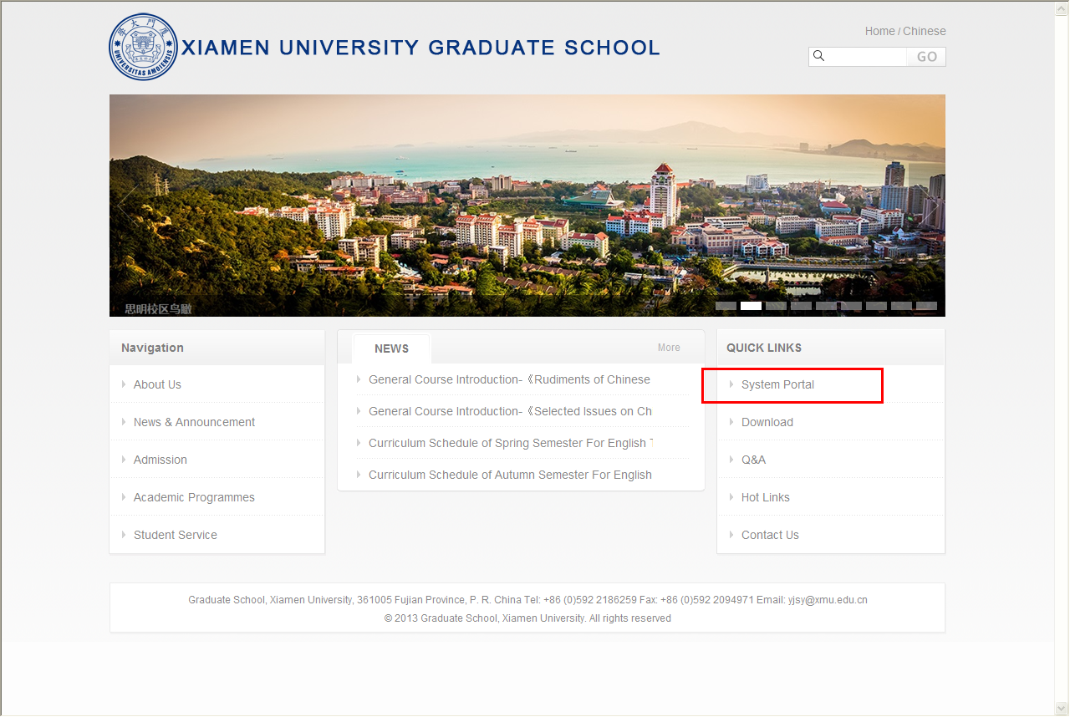
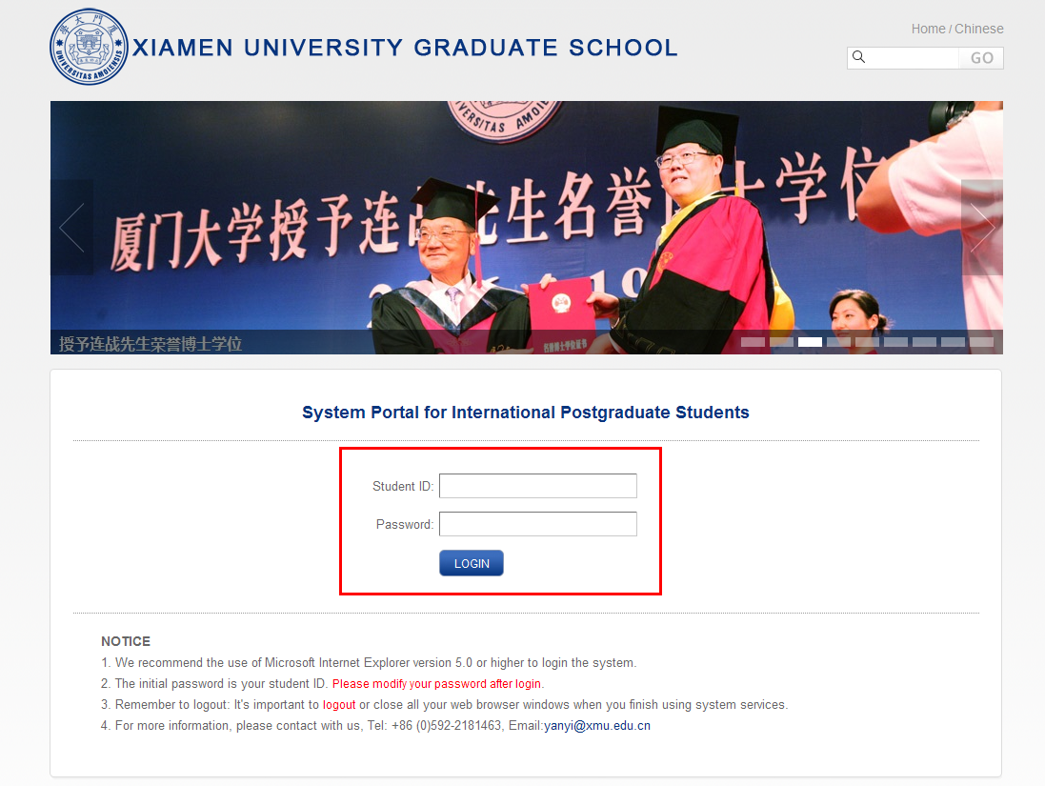
The initial password is your student ID. Find the modify password button to modify your password after login.

Find the “sign up for courses” button under the curriculum folder.
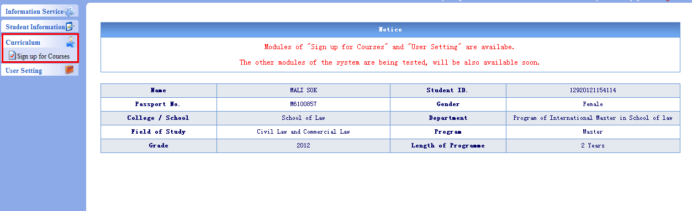

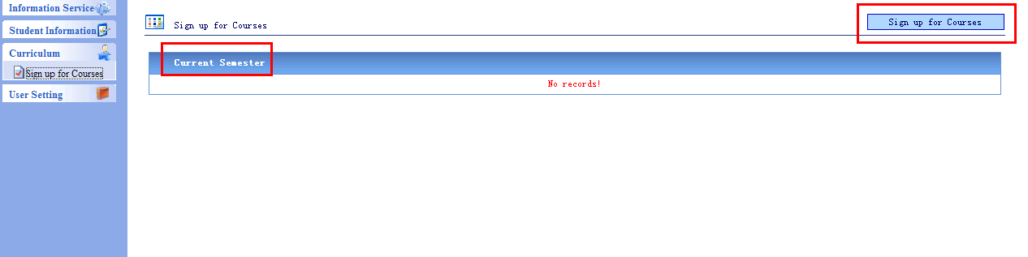

On this page，you can see the courses that you have selected and find the courses that you want to select. Click “details” to get more information.
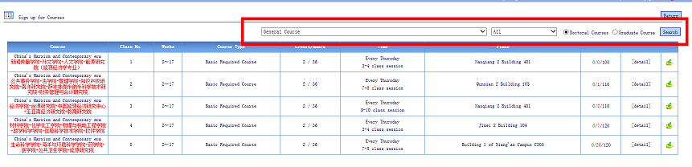

Use the drop-down list to view courses offered by different schools as illustrated below.
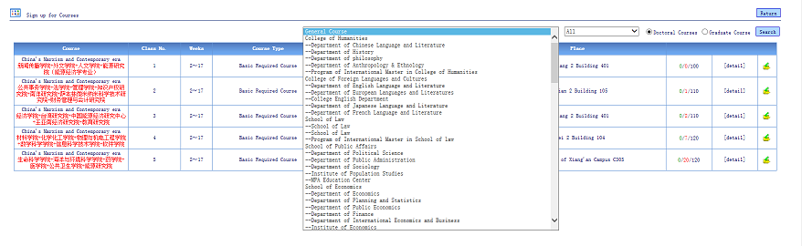

Choose “ALL” to search for courses of deferent type as below.
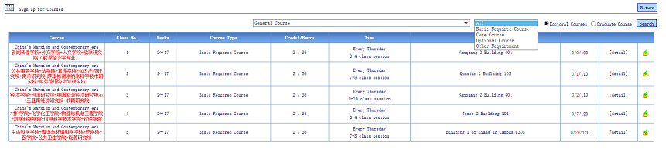

Click button to sign up for a course.
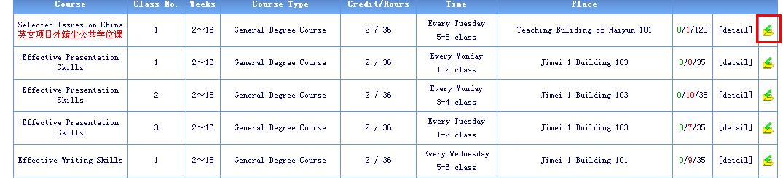

Click “YES” to confirm your course selection
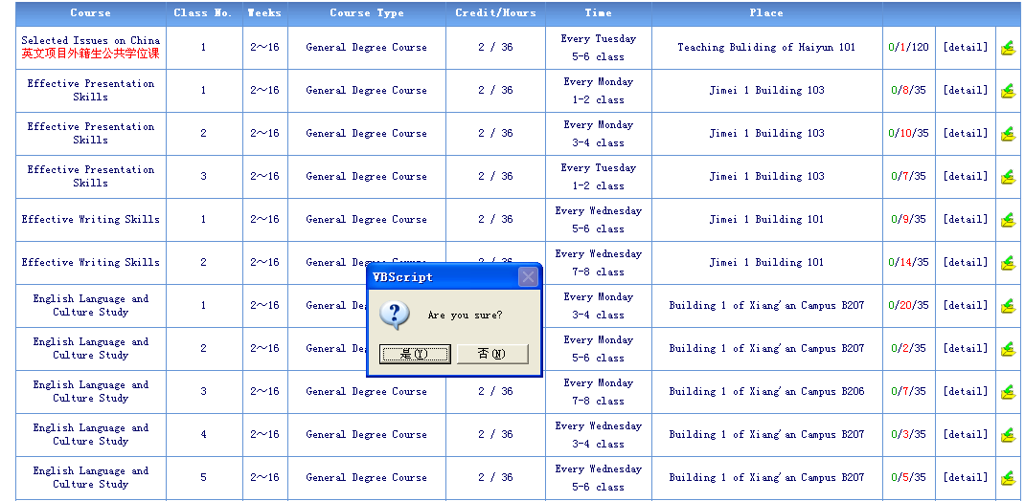

Go back to the “sign up for a course” page to check if the chosen course is on your course list.
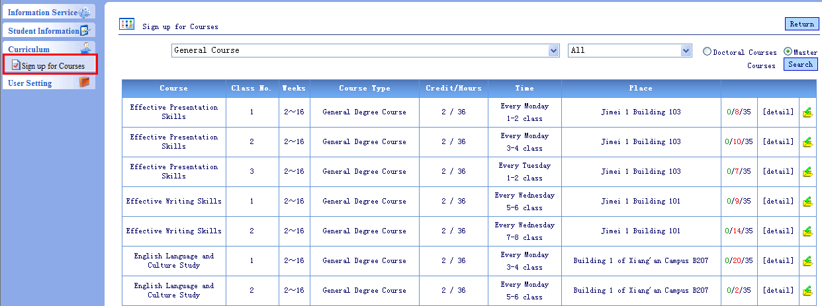

To drop courses just click the“”button.
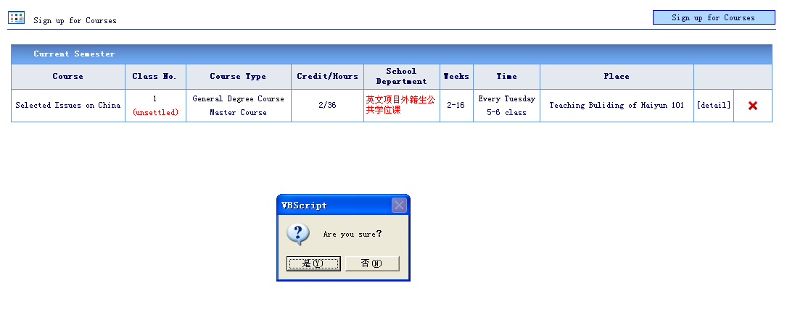

The red word “unsettled” means that the course has not been successfully chosen. If you successfully get into the class, the red “unsettled” will change to green “settled”. The course status will be changed after the deadline of each course selection period. Students who do not successfully register in their desired course(s) in the first or second period can choose to sign up for other available course(s) in a subsequent period. Students will not be able to register for courses after the course selection period ends.
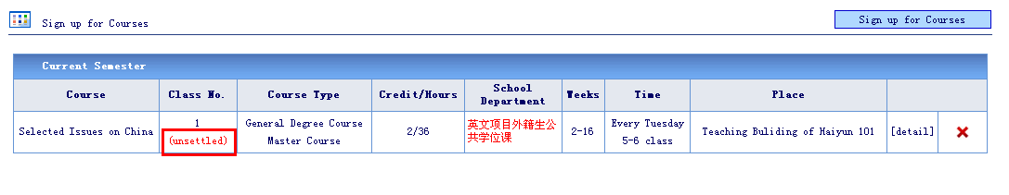

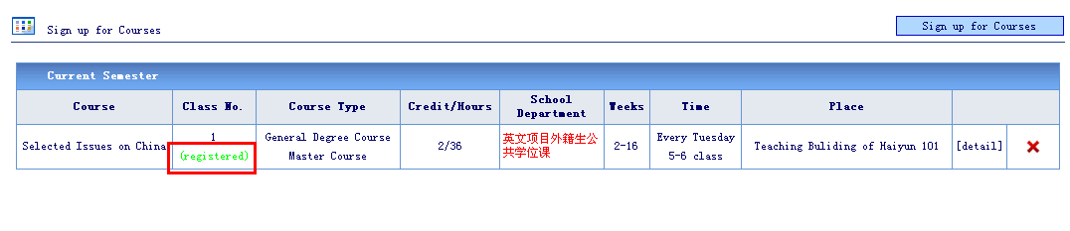

Graduate School General Courses Timetable
Courses | Instructors | Time | Campus |  | Lecture room
中国概况（Taught in Chinese）1 | Chang Daqun | Every Tuesday 14:30-17:25 | Siming Campus |  | Room 202,Nanqiang 2 Bldg.
中国概况（Taught in Chinese）2 | Chang Daqun | Every Monday 14:30-17:25 | Xiang’an campus |  | Room B313,NO.1 Bldg.
现代汉语通论（Taught in Chinese）1 | Zeng Xiaohong | Every Monday 8:00-11:50 | Siming Campus |  | Room 301,Nanqiang 2 Bldg.
现代汉语通论（Taught in Chinese）2 | Zeng Xiaohong | Every Wednesday 8:00-11:50 | Xiang’an campus |  | Room B213,NO.1 Bldg.
Selected Issues on China（Taught in English）1 | Liao Shaolian etc. | Every Tuesday 16:40-18:20 | Siming Campus |  | Room 104,Haiyun Bldg.
Selected Issues on China（Taught in English）2 | Liao Shaolian etc. | Thursday of even weeks14:30-18:20 | Xiang’an campus |  | Room B213,NO.1 Bldg.
Rudiments of Chinese Language（Taught in English）1 | Xiao Ningyao | Every Monday 16:40-18:20 | Siming Campus | School of Economics +Wang Yanan Institute for Studies in Economics+Center for Southeast Asian Studies | Room 401, Nanqiang 2 Bldg.
Rudiments of Chinese Language（Taught in English）2 | Xiao Ningyao | Every Monday 19:10-20:50 | Siming Campus | College of Humanities+ Institute for Financial &Accounting Studies+ College of Chemistry and Chemical Engineering + School of Law+ School of Physics and Mechanical &Electrical Engineering+School of Information Science and Engineering + School of Mathematical Sciences+ Institute of Education | Room 203, Nanqiang 2 Bldg.
Elementary Chinese Reading and Writing（1st） | Chen Dejun | Every Tuesday  16:15-17:45 | Xiang’an campus |  | Room B213, NO 2 Bldg.

*Select courses in accordance with campus.

